Taxi Trouble: Communication is key

Rob van Bekkum
Delft University of Technology,
Faculty of EEMCS
Mekelweg 4
Delft, 2628 CD, The Netherlands R.vanBekkum@student.tudelft.nl

Thijs Leo Martijn Brands
Delft University of Technology,
Faculty of EEMCS
Mekelweg 4
Delft, 2628 CD, The Netherlands
T.L.M.Brands@student.tudelft.nl

Seyed Soheil Jahanshahi
Delft University of Technology,
Faculty of EEMCS
Mekelweg 4
Delft, 2628 CD, The Netherlands
S.S.Jahanshahi@student.tudelft.nl
Aidan Carl Antony Mauricio
Delft University of Technology,
Faculty of EEMCS
Mekelweg 4
Delft, 2628 CD, The Netherlands A.C.A.Mauricio@student.tudelft.nl

Joost Johannes Egidius van Oorschot
Delft University of Technology,
Faculty of EEMCS
Mekelweg 4
Delft, 2628 CD, The Netherlands
J.J.E.vanOorschot@student.tudelft.nl

Copyright is held by the author/owner(s).

Abstract
In this document, the authors present the concept of the Android game Taxi Trouble, an interactive, competitive and collaborative multi-player game focusing on stimulating social interaction and entertaining large groups of people for a short timeframe.

Author Keywords
Competitive and Cooperative gaming; Social Interaction;

ACM Classification Keywords
K.8.0 [Personal Computing]: General – Games.
K.4.m [Computers and Society]: Miscellaneous.

Overview
Taxi Trouble is a racing game developed with the purpose to entertain large groups of people who need to stay in the same room for a considerable amount of time. It is designed with the purpose to let people interact with each other. The game requires players to verbally communicate with each other. This game was developed as part of a second year’s project at Delft University of Technology, The Netherlands.

Background Research
In various situations large groups of people have to wait together at big events like festivals for a fixed period of time. As unpleasant waiting experiences may lead to negative evaluations of service [1] it is important to have a means of entertaining these large groups to improve their waiting experiences. Computer games are not only a form of entertainment for individuals anymore [2], and so making people participate in an interactive, competitive and cooperative computer game is a well-fitting, but also challenging way of improving these experiences.
Collaboration takes an increasingly larger role in playing computer games. The elements that make a game entertaining and stand out are the presence of activities that require collaboration, a shared experience of playing the game and getting satisfaction as a result of socializing with a group of people [3]. An entertaining game should as well make its players feel in control, but at the same should have a sufficient portion of unpredictability so that its players will feel a form of satisfaction and pride when their shared goal has been reached [4].
On the other hand at the same time competition in computer games takes an increasingly larger role as well. Including competitive elements in games allows more active player engagement and yields in getting direct feedback on the players' actions [5]. As well playing a game against real people results in more involvement than playing against computer players [6].
Further it is important that a game for this specific context is of short duration and should be quite easy to understand as its players might only have a restricted available amount of time. As a consequence the game should not take long to setup and thus should be able to be played on almost every location.

Design and Development
Gameplay has become an integral part of the lives of many people especially when it comes to social interaction and communication. Based on our research we have designed our game model by creating a taxi which needs to be steered by a driver who is guided by a navigator. Each user of the game will take a role of either driver or navigator and will play the game through their respective view.
A screenshot of the driver view and the navigator view will be added here.
They then team up as a pair in the waiting room to start playing the game. The players are guided to the game by start menu where options are available for them to choose either to play the game or to view the leaderboard.

We applied MVC (Model View Controller) as design pattern to divide the application into three kinds of components, the model, view and controller. The controller sends commands to its associated model to change the model’s state while the game is being played. The model will notify its associated views that it has been updated and the view will update to show these changes accordingly.

Testing and Evaluation
Just before our product entered the beta stage, we held a User Test at Science Centre Delft. We choose this location on purpose as it mostly attracts people who are part of our target audience (ages 12-30).
Our test indicated that it is a bit troublesome figuring out how to play the game, as ##% needed five minutes to completely understand the game. Once users understood the game, they all started communicating with each other. This showed that the “forced communication” aspect of the game really worked as intended.
The most important part of feedback we got was that players found that, while the game was fun to play, they felt that it was a bit too easy to score points. This was very valuable feedback to us and it resulted in the addition of a time constraint. This means that the actions necessary to score now have to be executed within a certain time frame. We found that this additional feature made our game more challenging and fun to play.
Despite the absence of this time constraint, users found our game a huge success, as nearly everyone said that they would like to have the game.
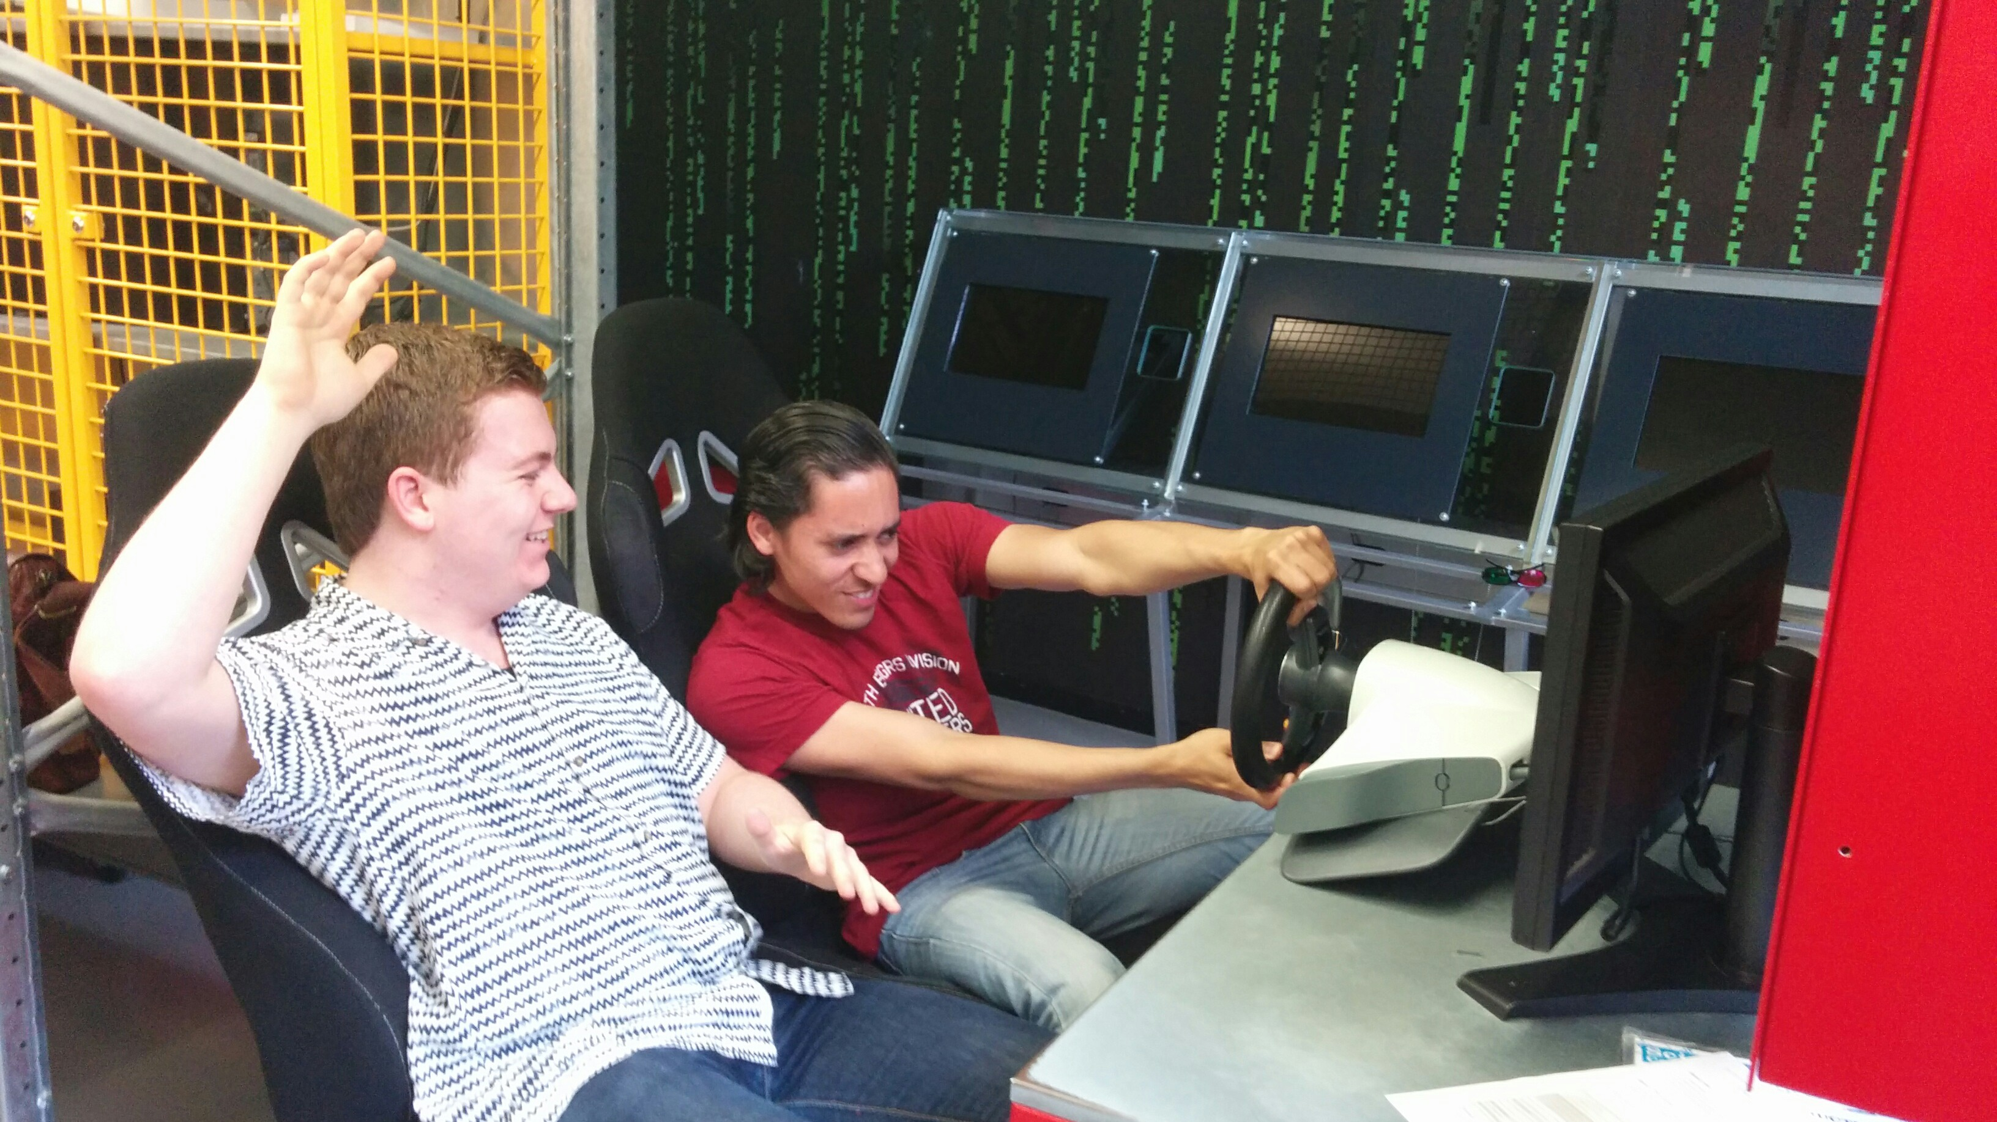Figure 1. Our test location. Unfortunately, the steering wheel is not used.
A table with test data will be added here in the final version.

Acknowledgements
We would like to thank Delft University of Technology for facilitating the development of taxi-trouble. We would like all the professors and teaching assistants concerned with organizing the context project. Special thanks go out to Rafael Bidarra, Bastiaan Reijm and Fanny Lie for supporting us throughout development. We also like to thank Jan-Willem van Velzen for his work on our art assets. Last but not least, we want to thank Science Centre Delft for facilitating our user tests.

References
[1] Yan, R.N. and Lotz, S. (2006). The Waiting Game: The Role of Predicted Value, Wait Disconfirmation, and
Providers’ Actions in Consumers’ Service Evaluations. In NA - Advances in Consumer Research, Volume 33, eds. Pechmann, C. and Price, L., pages 412-418, Duluth, MN, USA, ACR.

[2] Sellar, T. (2004). User experience in interactive computer game development. In Computer Human Interaction, pages 675-681.

[3] Ducheneaut, N. and Moore, R. J. (2004). The social side of gaming: a study of interaction patterns in a massively
multiplayer online game. In Proceedings of the 2004 ACM conference on Computer supported cooperative work,
CSCW ’04, pages 360-369, New York, NY, USA. ACM.

[4] Granic, I., Lobel, A. and Engels, R. C. M. E. (2013), The Benefits of Playing Video Games. Radboud University.
Nijmegen, NL.

[5] Vorderer, P., Hartmann, T., and Klimmt, C. (2003). Explaining the enjoyment of playing video games: the role
of competition. In Proceedings of the second international conference on Entertainment computing, ICEC ’03,
pages 1-9, Pittsburgh, PA, USA. Carnegie Mellon University.

[6] Cairns, P., Cox, A. L., Day, M., Martin, H., and Perryman, T. (2013). Who but not where: The effect of social
play on immersion in digital games. International Journal of Human-Computer Studies.

